**Appendix 1**

**Existing Controlled Parking Zone (CPZ) Review – Background Information.**

1. To identify a programme of existing zones for review, Oxfordshire County Council officers initially used levels of historic requests and complaints to identify a top 10 priority list of CPZs which may require wider assessment and informal consultation.
2. This work was further advanced to include indicators including:

* Age: Older CPZs have been given a higher priority as they are more likely to have outdated parking controls.
* Deprivation: Based on collated deprivation indexes for each zone. More deprived areas resulted in a higher priority weighting. A CPZ review gives opportunities to implement changes to improve social mobility, including car club bays and improve barriers to cycling and walking within CPZs.
* Parking Capacity: Based on theoretical on-street demand vs number of permits issued by street. Zones with higher demand for current capacity have been given a higher priority score.
* Number of Complaints: The number of complaints / requests has been weighted against the other indicators.

1. Three of the top 10 zones identified for review, have been implemented in the past 3 years: South Oxford (extension), Cowley Centre (East) and Cowley Centre (West), with reviews completed as part of post scheme survey.
2. The remaining 7 zones within the top 10 priority areas are ranked in **Table 1** below. It is proposed to complete all reviews, including any associated works, by financial year 2027/28.

|  |  |  |  |  |  |  |
| --- | --- | --- | --- | --- | --- | --- |
| ZONE | AGE | DEPRIVATION INDEX | CURRENT CAPACITY | No. REQUESTS | WEIGHTED SCORE | PRIORITY |
| East Oxford | 3 | 5 | 5 | 4 | 4.5 | 1 |
| Headington Central | 4 | 1 | 5 | 5 | 4.3 | 2 |
| Summertown | 4 | 1 | 5 | 3 | 3.85 | 3 |
| Temple Cowley | 1 | 2 | 3 | 5 | 2.95 | 4 |
| Headington West | 5 | 1 | 3 | 2 | 2.8 | 5 |
| Florence Park | 1 | 3 | 2 | 1 | 1.8 | 6 |
| Cutteslowe | 2 | 3 | 1 | 2 | 1.65 | 7 |

**Table 1: Proposed priority list for CPZ reviews**

1. The County Council have indicated that the requested £358,080 includes staff costs, design, consultation and implementation and an allowance for contingencies, such as risk and increased costs (for example, the higher costs of replacing signs).
2. The location of all existing CPZs is shown in **Figure 1** below, with the zones identified for inclusion within the review coloured. A map of all existing CPZ’s is also available to view on the Oxfordshire County Council’s website using the following link: <https://oxfordshire.maps.arcgis.com/apps/Styler/index.html?appid=6055cb5fa36f4ababdcadbe35a99a5e6>

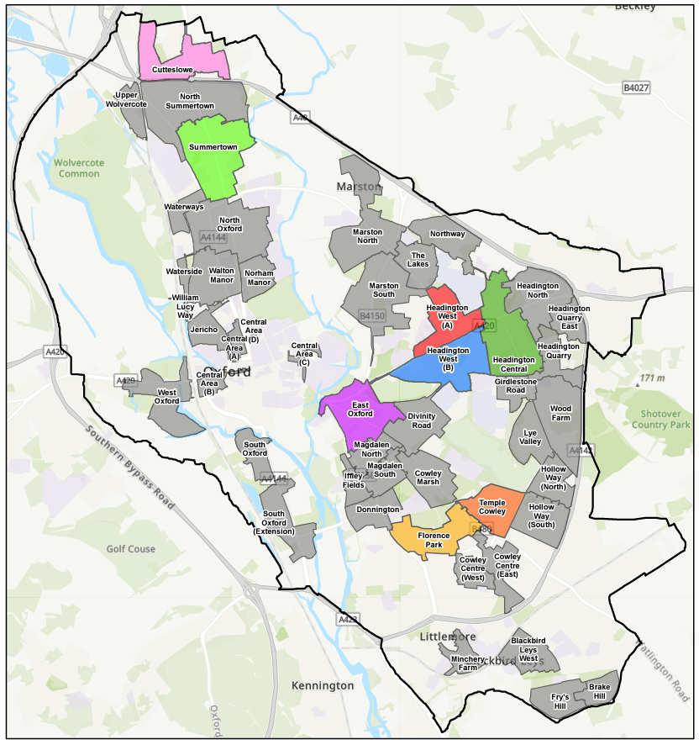

**Figure 1** – Controlled Parking Zones within Oxford City,

n.b. zones that are included as part of the review are coloured.